VISUALS  Fades from Black  Quick shots of different movies that come from Criterion Collection films such as Some Like It Hot, The Asphalt Jungle, Mildred Pierce, and My Man Godfrey  The Criterion Collection logo transforms into the Criterion Channel Logo  The logo fades out away showing the criterion.com link  Flash of the tagline “Enrich the eyes, deepen the experience”  Fades to black | AUDIO AND SCRIPT  Happy Upbeat Clapping stock music Fades IN at :15 second mark *  You know us for the Criterion Collection, would it be nice if you were able to stream our collection?  We are introducing the Criterion Channel a new streaming service launching in Spring of 2019  Learn more and become a Charter subscriber at criterion.com!  Criterion Channel… “Enrich the Eyes, deepen the experience”  Happy Upbeat Clapping stock music fades out at  :30 second mark
Name: Nicholas Krasoski
Project: Criterion Channel Television Ad
Duration: 15 Seconds

Social Media Posts

Introduction: I wanted to create four images that included textless movie posters I managed to get off the Creative Commons website. I made a special logo for The Criterion Channel with a launch of Spring 2019. I then intertwined all these pieces into what will be showcased down below with captions of what I compiled using Photoshop. The ‘C’ art is the actual logo of The Criterion Collection that I pulled off WikiMedia commons, so I do not get in trouble with copyright. I wanted to go between Twitter, and Instagram as conversations/interactions for films are considered the heaviest scrolling through posts on The Criterion Collection’s social media pages. I would say I want my target audience to be 18-35 with a secondary audience of overall film lovers. The product I am advertising is such a niche product that I want to use movie posters as a way of expressing the idea of The Criterion Channel “Coming Soon to a Theater near you” sort of thing. Finally, my last post will be a simple tweet for twitter including links because you cannot include links for Instagram unless its explicitly in the bio on your main user page.

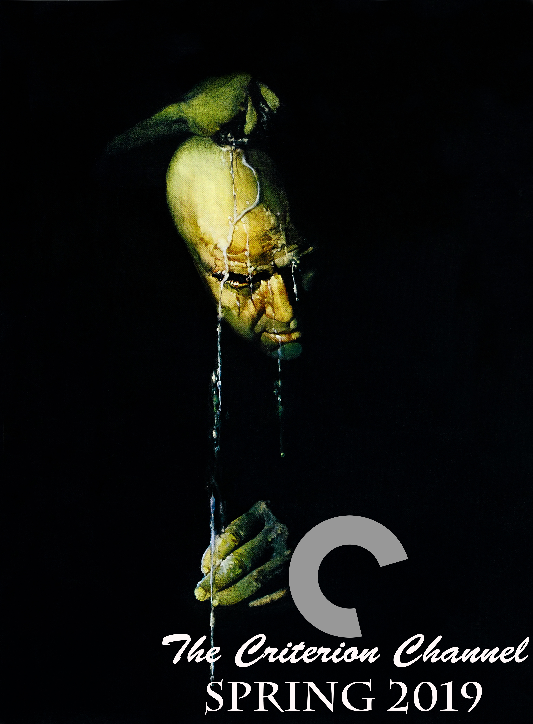

Twitter/Instagram: Watch epic films like Mildred Pierce and many more when The Criterion Channel Launches in Spring 2019. Enrich the Eyes, deepen the experience. #Criterion #Streaming #Classics #Art

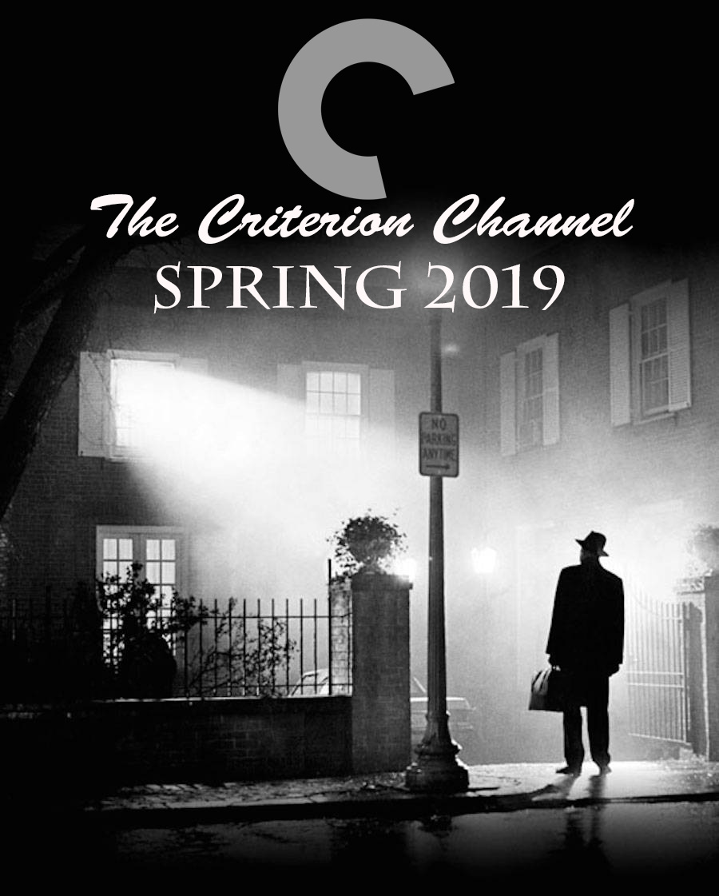

Twitter/Instagram: “One way or another, we all work for our vice.” Have the Criterion Channel become your vice when it launches in Spring 2019! #Criterion #TheAsphaltJungle #film

Twitter/Instagram: Coming soon to a streaming device near you! The Criterion Channel will be launching in Spring of 2019!

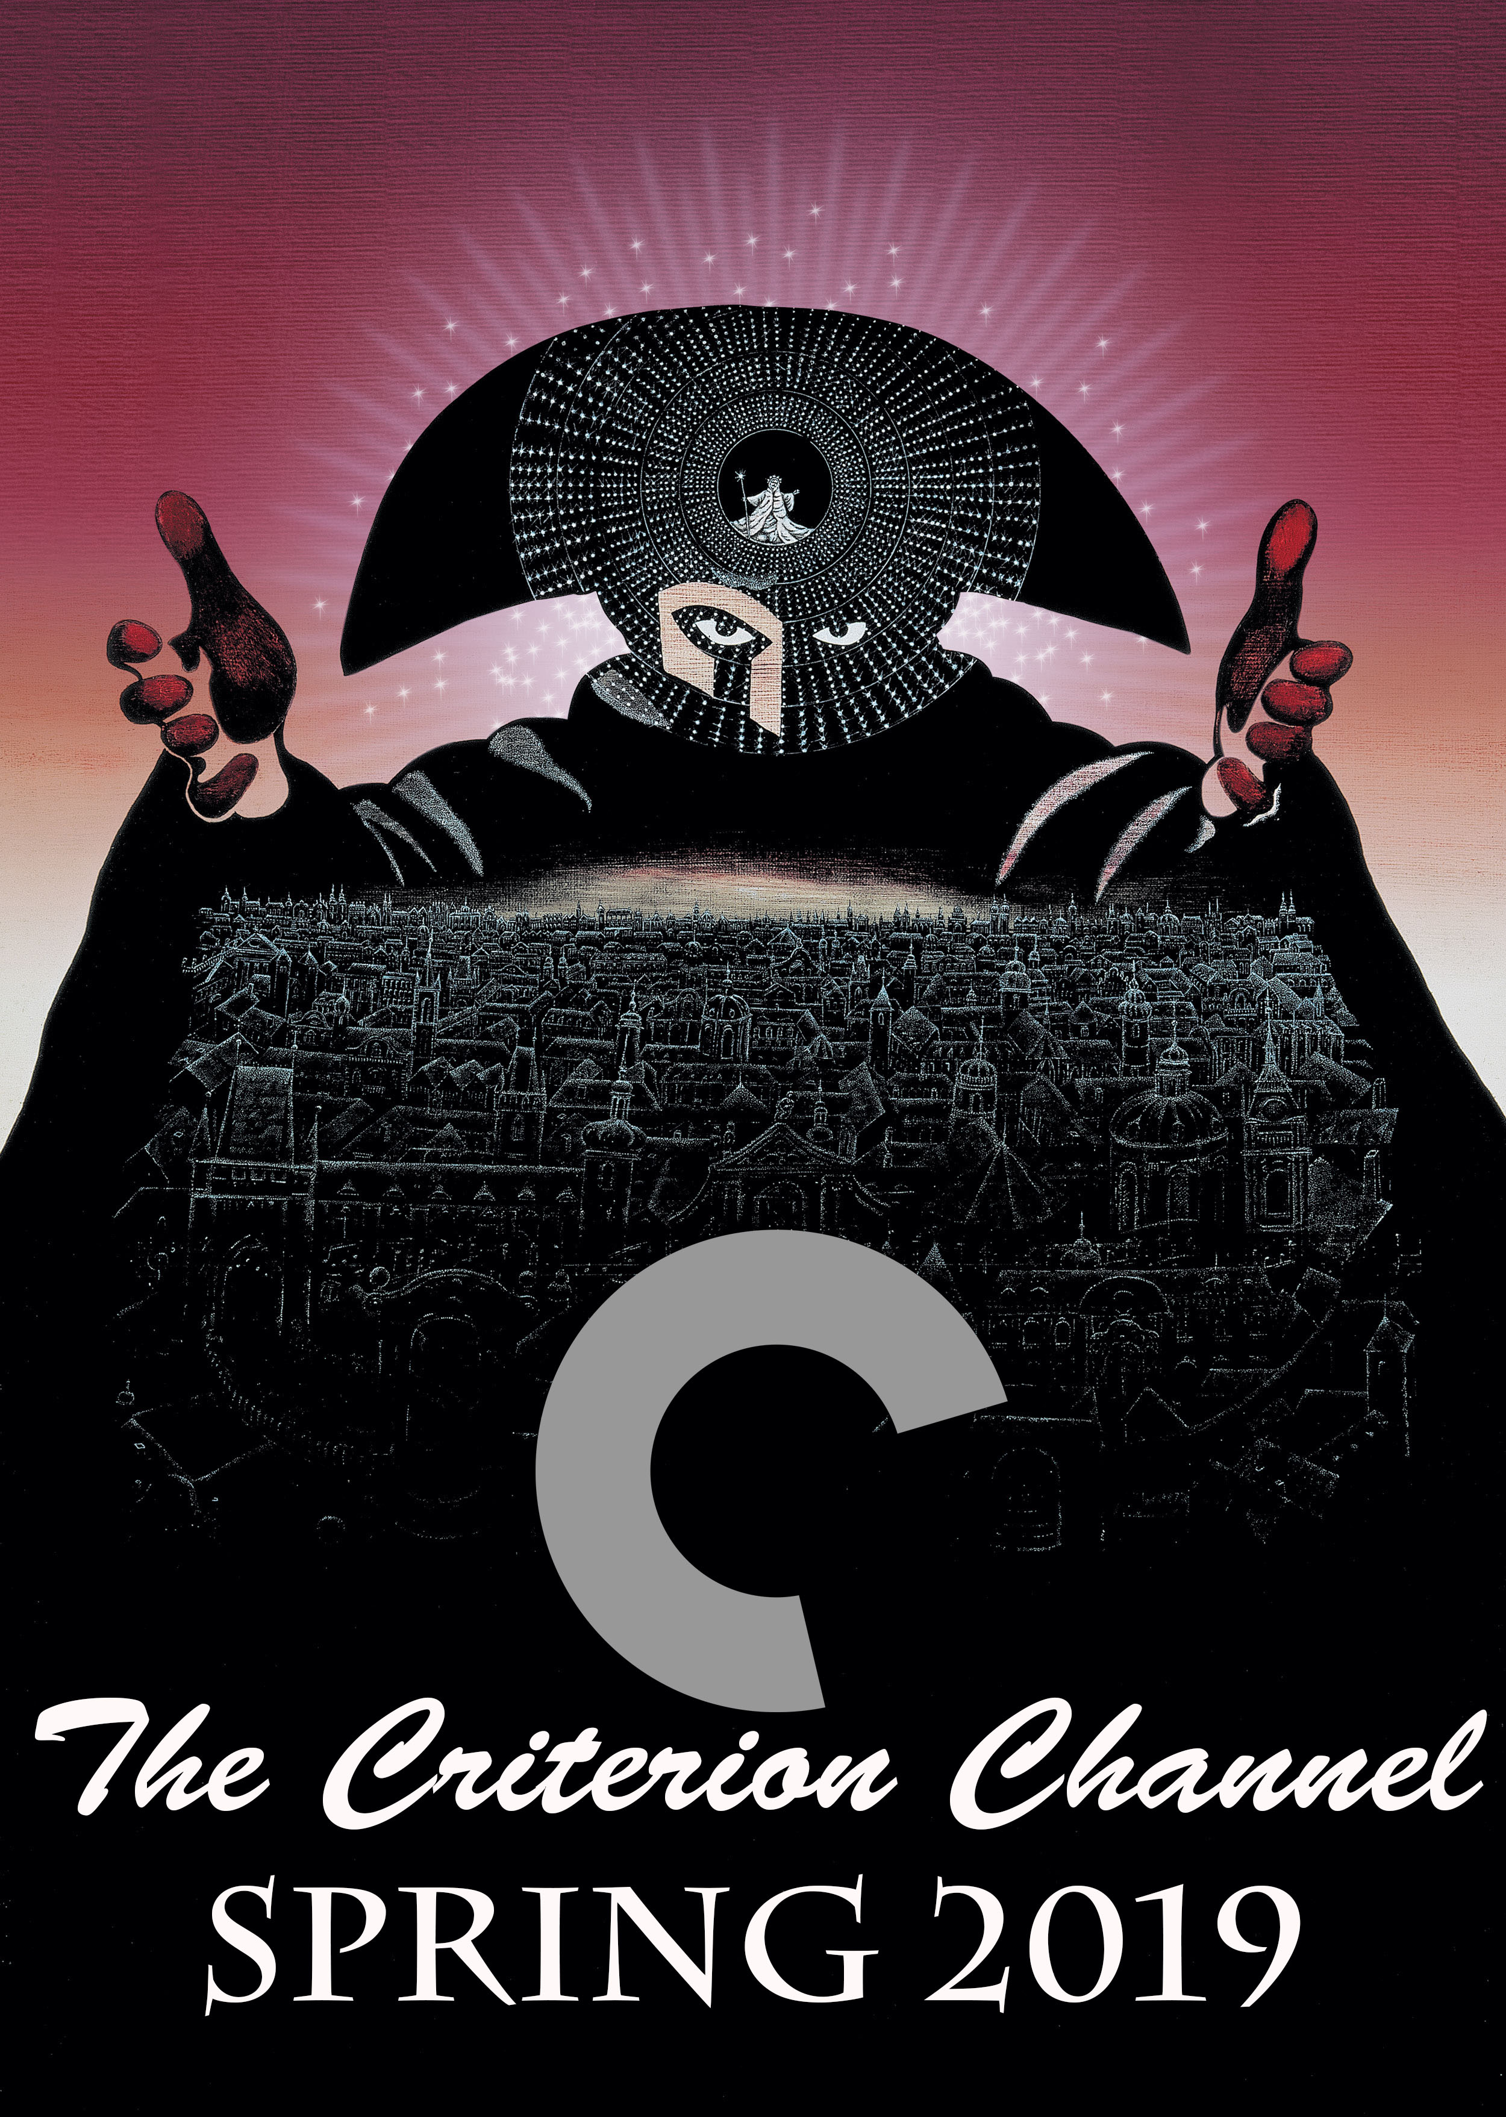

Twitter/Instagram: Snare the senses… Enrich the MIND. Watch a plethora of Films available for streaming stemming from foreign films to classic noir dramas! The Criterion Channel is launching in Spring 2019!

Twitter: Coming soon to a streaming device near you. The Criterion Channel launches Spring 2019. Experience films the way they were meant to be! Enrich the eyes, deepen the experience! Become a charter subscriber at criterion.com #Criterion #Streaming
- Just at the 240-character limit
Script  I had to let ya kiss me. I only did it because ya begged me. Ya hounded me and drove me crazy! And after you kissed me, I always used to wipe my mouth! Wipe my mouth! -Of Human Bondage 1934  Like what you heard? How about watching it!  Films like Of Human Bondage starring Bette Davis will be available in Spring 2019 with the Criterion Channel  The Criterion Channel will be a state-of-the-art streaming service with carefully curated films that are coming from our own Criterion Collection  We hope to see you there! Become a charter subscriber at criterion.com, and see what films will be available at launch  Criterion Channel…”Enrich the eyes, deepen the experience” | SFX  Bette Davis’s dialogue fades in  Bette Davis’s dialogue fades out  Johannes Brahms - Piano Concerto No. 2 in B-flat major, Op. 83 - II. Allegro appassionato Music fades in at 5:46*  Johannes Brahms - Piano Concerto No. 2 in B-flat major, Op. 83 - II. Allegro appassionato Music fades out at 6:10*
Project: Criterion Channel Radio Ad
Duration: 30 Seconds

