Nicholas Krasoski
Professor Deater
ENG388 Film Genre
11 November 2018
What is Film Noir: A History and Select Film Analysis
Film noir is one of the most influential concepts of the golden age of Hollywood. In the 1930’s, Hollywood provided a glamourous escape from the harsh realism of The Great Depression with studios such as Metro Goldwyn Mayer churning out a large number of movies a year. The big Hollywood studios such as Warner Brothers, MGM, RKO came out with a variety of movies spanning in different genres such as musicals, dramas, and comedies. It was not until the 1940’s when the United States entered World War II where more mature themes were explored within American cinema. Although those types of films were continually released during wartime, film noir erupted on the scene showcasing the dark depths of America involving murder and femme fatales. It is important to note how film noir came to be by studying its origins, and what films made a graceful impact. Film Noir can be considered its own genre or a sub-genre within itself. Overall, it is an umbrella term that showed America, that the characters in these stories have a side of darkness that has not been shown before to audiences. Critics, and film historians alike have argued whether or not film noir is a genre, or a style of movie. The term “Film Noir” got its name beginning in 1946 by French critics. “Down the mean streets of film noir walk hardboiled detectives, slinky femme fatales, and all manner of corrupt and brutal criminals. What follows is an introduction to the genre of dark American thrillers that mirrored the urban malaise and social anxieties of the 1940s and 1950s” (Sehayek). The concept of film noir is difficult to explain, writer for online publication “Culture Trip” Marnie Sehayek explains it nicely with her article “A Very Brief History of Film Noir”. This is a great article to read as a primer before delving deeper into the origins of film noir. One important detail she explains is how these movies were shot and how it affected audiences, “directors utilized high key cinematography that dominantly featured bright direct light, and cascading shadow, off-kilter camera angles, and asymmetrical compositions to emphasize spooky or sordid storylines meant to thrill and intrigue.” (Sehayek). What is great about film noir is the stylistic approach to it, how actor’s actions were framed in the shot, and how their psyche gave an added suspense. Next is how the story plays out based on the consequences of their actions. Although Sehayek’s article is a great preface to film noir, one book goes in depth on the complete history of noir. “A Panorama of American Film Noir” is one of the first books that was ever written that chronicled Film Noir. The book was originally written in French by critics Raymond Borde and Etienne Chaumeton and translated to English by Paul Hammond. They open their book by trying to create a definition that explains film noir. The authors lament saying that there is no clear definition of what noir is, that it has to have many aforementioned attributes to be considered a noir. “Film noir is noir for us; that’s to say, for Western and American audiences of the 1950s. It responds to a certain kind of emotional resonance as singular in time as it is in space. It’s on the basis of response to possible ephemeral reactions that the roots of this ‘style’ must be sought” (Borde et al. 5). The common motif of noir consists of uncertain motives of the heroine. The authors explain the heroine as “vicious, deadly, venomous, or alcoholic. The hero lets himself be led astray, gets to ‘take a lot of punishment,’ as they say in boxing, during ruthless settlings of scores.” (Borde et al. 12). By the same token, once the cruel act of murder occurs, no one feels resentment until the final moments of the film. That these films resound a traumatic ending that lead the audience of many directions, primarily questioning the mysteries eluding from these films to be solved. Early plots within film noir were often based on novels that were rooted in the detective genre that exploded in 1925. “The Maltese Falcon”, a film that is considered to be the first noir ever came from a novel written by Dashiell Hammett. “The immediate source of film noir is obviously the hard-boiled detective novel of American or English origin. Dashiell Hammett, whose earliest writings go back to around 1925, is both the creator of this new American literary current and an author whose talent largely transcends the framework of the genre.” (Borde et al. 15). The first handful of noir films were merely adaptations as compared to original screenplays. Film studios were reluctant to over produce these kinds of films, and exercised caution upon adapting these novels. On the other hand, movies made after these novels and so forth were consistently linked to the study of psychology. Psychology is important to note because the characters in these films cannot act without motivation. A common character type the authors from “A Panorama of American Film Noir” is the gangster. “The gangster, is a neurotic whose behavior can be fully understood only in utilitarian terms; aggressiveness, sadism, and masochism are self-serving; the interest in, or love of, money is often only a cover for libidinal fixation or infantile conflict.” (Borde, et al. 19). So, if we can understand the underlying frameworks of noir, how does that attune to its cinematic philosophy? Robert B. Pippin’s introduction in his book “Fatalism in American Film Noir: Some Cinematic Philosophy” not only adds significant detail to what is previously mentioned but how and why it came to be. He begins by explaining that noir is “almost always about crime, usually murder, often cold-blooded, well-thought-out murder.” (Pippin, 6). To take what is portrayed within noir films, the realism associated with it and how it was affiliated with American life. The timeline of Noir began during World War II and then continued beyond after it was over. Why did these movies with depressing and plots that create anxiety attracted such a consistent audience? “That is deeply interesting question, and movies have often been important pieces of evidence for sociological and historical interpretations of the temper of the times.” (Pippins, 7). The assertion of movies reflecting the sign of the times can be very true. It can be seen in films during the 1930’s creating a falsehood, by showcasing glamour and high fashion of 30’s actresses to audiences who were suffering from the effects of The Great Depression.
Besides adapting from novels and using psychology of characterization and post war United States influenced film noir, it is imperative to review how budgets given to these movies effected the end revenue gained, and the whole movie industry. Noir films made between 1941 to 1945 often had a low budget, and “The Maltese Falcon” can attest to that. Film budgets often set the stage to the overall potential of the film, “The Maltese Falcon” suffers from this lack of means: there are a lot of apartment scenes, few characters, no extras, a dearth of technical innovation, A star is called in, Humphrey Bogart, who appears to be over the hill, and a director, John Huston, whose first film this is.” (Borde, et al. 16). “The Big Screen: The Story of The Movie”s by David Thomson, a narrative of cinema as a whole offers insight on why there was reluctance with noir filmmaking during World War II. “During the war, there was a gentleman’s agreement in Hollywood to ease off on making gangster pictures, because they might present the nation in a poor light. But later, many noir films were B pictures, shot quickly on low budgets because the noir area of the screen saved on décor.” (Thomson, 230-231). In accordance to noir, gangster pictures are not exclusively tied to the genre, but have been made time and time again previously prior to World War II. In light of the United States, becoming one of the most powerful countries in the world after World War II, the reluctance of Hollywood producing noir films could give the country a bad reputation among its allies by viewing the country as a toxic wasteland for crime. Film noir directors such as Billy Wilder and Howard Hawks have created some of the most pivotal films of the genre. Back then these directors were not just tied to one genre, they often directed dramas, and comedies as well. Billy Wilder is known for directing noir favorites such as Sunset Boulevard and Double Indemnity. Other than that, he directed big hits such as the Marilyn Monroe vehicle Some Like it Hot. Howard Hawks directed two popular Warner Brothers noir films such as To Have and Have Not, and The Big Sleep. Both of these films starred Humphrey Bogart, and Lauren Bacall, who were two prolific actors known for their performances in noir films. Hawks also directed screwball comedies such as, Bringing Up Baby, and one of my favorites, His Girl Friday starring Cary Grant, and Rosalind Russell. Billy Wilder, originally born Samuel Wilder on June 22nd, 1906. He is from Sucha, Austria which is currently Poland. He began working on scripts for many German and French films, but when the rise of Nazis who took power in 1933, Wilder and many others fled. He relocated to Paris, France in which he co-directed the film Mauvaise Graine. He then spent a brief time in Mexico, before living in the United States until his death in 2002. Billy Wilder was known to include subjects within his film that were deemed inappropriate for standard American audiences. He included topics like alcoholism, prisoner of war camps, prostitution, and emptiness of modern life such as Sunset Boulevard (Britannica, 2017). One Iconic film, Double Indemnity is one of Billy Wilder’s best. The film was based off a serial published in Liberty Magazine, originally written by James M. Cain. It stars Barbara Stanwyck as Phyllis, and Fred MacMurray as Walter. A brief synopsis of the film is about Phyllis who so tired of her husband’s abuses against her that she wants him dead. Walter initially goes to Phyllis’s family home to sell them insurance. He meets Phyllis alone and that is when they form their affair and concoct the plan to take her husband out. Barbara Stanwyck is known to play characters to be from the “other side of the track”. Babrara Stanwyck’s dramatic rolls trace back to a lot of early films including playing Lilly in Baby Face. The aesthetic of Double Indemnity is interesting to note. The film is shot primarily in black & white, noir films are never shot in color. Stanwyck’s hair in the film is platinum blonde, which was a wig since Stanwyck’s natural color was a dark brown. The settings went between Walter’s apartment complex, and Phyllis’s Hollywood Hills two story home. In the book, Conversations with Wilder by Cameron Crowe, the author discusses with Wilder on his choices for the settings of Double Indemnity. “Like for instance, Double Indemnity. I had to find a house that is typical for a guy like the husband of Barbara Stanwyck. Two stories I wanted, because I wanted the photograph her coming down the steps with the anklet” (Crowe, p. 53). That scene in the home is one of the first key sequences of the film. When Phyllis and Walter first meet, the long shot of Phyllis coming down the semi spiral staircase zooming in on her legs coming out of her robe and wearing the ankle bracelet. The score for Double Indemnity was also intense, with scenes of trauma the score would become heavy. When Walter and Phyllis follow through their plan with murdering her husband that film was one of the most pivotal key sequences in the film. Phyllis is driving her husband to the train station because he has a business meeting out of town. Walter is hiding in the back seat on the floor while she drives her husband to the station. The plan was for Phyllis to beep the horn three times to signal Walter to commence the murder. When she beeps her horn, the cameras close up shot on her looking panic stricken throughout the whole event, and the orchestrated music intensifying. Ultimately, you hear her husband yelling “what’s going on”, as he grunts when Walter puts his hand over his mouth to choke him.
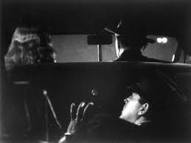 | 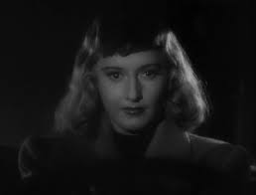

Another more iconic film of Wilder is Sunset Boulevard. Which is one of my personal favorites. Wilder’s goal for the film was to highlight the archetype of forgotten Hollywood. The project of the film was kept secret to many in Hollywood because Wilder knew studio execs did not want to show audiences the harmful side of the business. Louis B. Mayer, head of MGM had great distaste for the film. “You Bastard… You have disgraced the industry that made you and fed you. You should be tarred and feathered and run out of Hollywood.” In which Wilder replied, "Fuck you". (Independent, 2003). It stars old silent era star Gloria Swanson, as Norma Desmond, and William Holden, as Joe Gillis. The film comments of the harsh reality of silent era movie stars and how the transition to talkies either grew their career or ended it. Many of these silent stars did not like the notion of sound, and a lot of them just simply did not sound good on microphone. Gloria Swanson was not Wilder’s first choice for Norma Desmond. He had his eyes set on Mae West, who declined the role because she felt she was at the prime of her life. Then he offered it to former silent star Mary Pickford, who denied the role out of being offended for what it entailed. It was fellow director, George Cukor who suggested Gloria Swanson for the role. (Crowe, 47). Gloria Swanson was a great fit for the film, her dramatic actions made the film for what it is. Silent film stars did not have dialogue they had accentuate their movements for the audience to understand the films premise. In which her character Norma lamented “We didn’t need dialogue. We had faces!” The film was released in 1950, and exemplified the time warp that Norma was stuck in. Tucked away in her almost run-down mansion away from the real world with her butler, Max. William Holden’s character, Joe Gillis is a screenwriter who is having a hard time finding work. He gets chased by debt collectors trying to take back his car, after the chase the men shoot at his tire and gives him a flat. He pulls into Norma’s home and hides in her garage. From there he introduces himself to Max at first then Norma. Norma discovers he is a screenwriter and presents him her overly long script for her film Salome to edit. She wants it perfect, so she can pitch it to real life director Cecil B. Demille. She hopes this film will mark her return instead of a comeback as a famous movie star. Norma begins to fall in love with Joe and wants to eliminate his debts and take care of him, something Joe does not want. Instead he falls for his friend’s fiancé, a script editor named Betty. Norma catches wind of it and goes in a psychological frenzy causing her to get a gun to commit suicide. But the overall end event is of Norma shooting Joe dead. It is hard to narrow down key sequences because the film is just one big key sequence. Wilder originally intended for the film to open in a morgue where we see the blanket over Joe’s body but changed his mind (Crowe, 45).
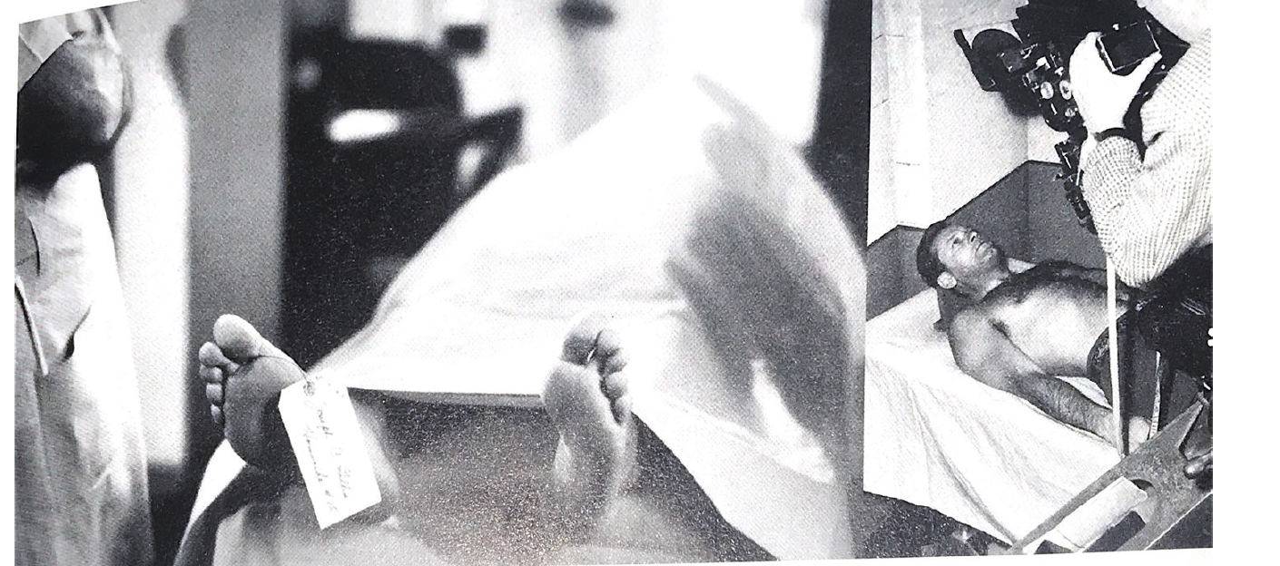
Instead it opens up to the camera being inside the pool where Joe’s dead body floats face down and, in the background, he is narrating posthumously how he ended up dead in the pool. The setting of the film primarily takes place in Norma’s estate, with some scenes taking place on the Paramount Studios lot. The film Double Indemnity is shot in black and white. The costuming shows Norma wearing a lot of elaborate dresses that came from the 1920’s, while Joe wears a normal suit that associated itself with the late 40’s- early 50’s era garment. Some enjoyable scenes of the films included early on in the film in which Norma makes Joe watch one her films in the living room. In which she exclaims that she will be back up there so help her. The way that scene was shot was amazing, the room was primarily dark with only the flickering light of the projector. When she stands up and exclaims her return to the screen with the dust of the room, the cigarette smoke filing through the frame, and Norma’s shadow reflecting from the flickering projector light is one of its finest moments.
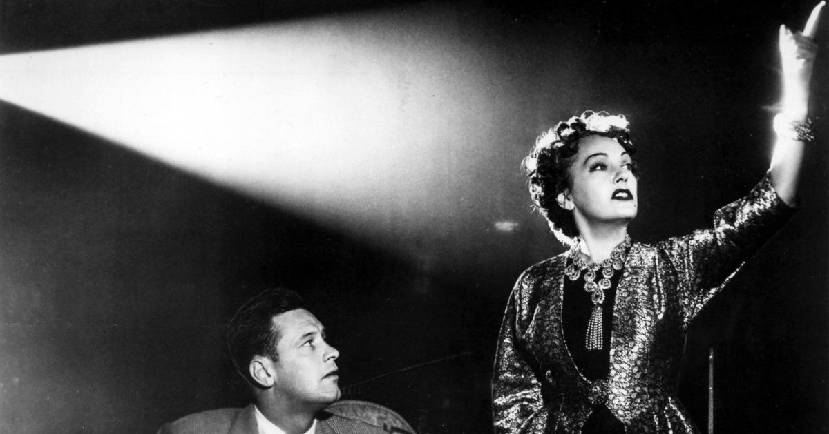
One thing the film is primarily known about are the popular quotes that stem from it. Finally, the most iconic line is “Alright Mr. Demille, I am ready for my close up.” This is when we see Norma finally snap, she is so far away from reality. This is after she shoots Joe dead, the house is filled with newspaper men and cameras. To Norma, all the ramblings surrounding her home convinces her that she is on set. The penultimate scene is Norma coming down the spiraling staircase, something common it seems with Wilder films. The people surrounding her are frozen as she waltzes down the stairs. But in reality, the people around her are wondering what is going on in her mind. Consequently, the film closes to Norma easing into the camera like she is shooting a scene for Salome, and the frame blurs and fades to black.
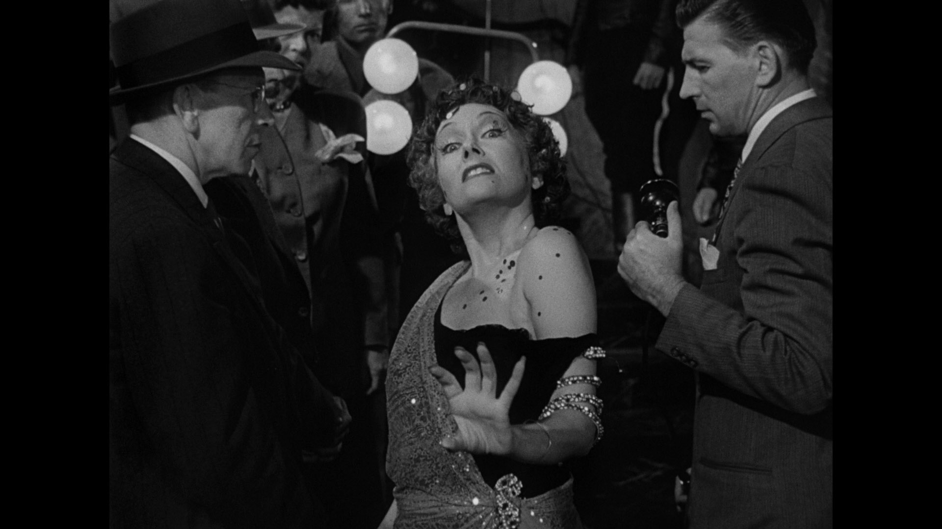
“Alright Mr. Demille, I’m ready for my close up” – Norma Desmond
Howard Hawk’s was a strong-arm director of noir films for Warner Brothers. Howard Hawks was very versatile, he directed comedies, musicals, noir, and science fiction. He was one of the few directors who were not contracted to a single studio. Hawk only made 33 sound films. Hawks actually directed a film written by Billy Wilder, a romantic comedy starring Gary Cooper, and Barbara Stanwyck, Lauren Bacall credited Howard Hawks for blossoming her career as a popular actress in the 1940’s. During pre-production of To Have and Have Not, Hawks was struggling finding a female lead. It was his wife who discovered Lauren Bacall modeling in Vogue magazine and asked Hawk’s to potentially cast her. That film is based off the novel of the same name written by Earnest Hemmingway and was a box office success for Warner Brothers and everyone involved. This prompted Warner Bros to hire Hawks again to direct another big noir hit including Humphrey Bogart and Lauren Bacall, and that ended up being The Big Sleep (Britannica, 2014). Like many noir films, it was based off of crime novels. The Big Sleep was written by Raymond Chandler, and to be adopted to screen by Howard Hawks. The film revolves around Detective Phillip Marlowe, played by Humphrey Bogart accepts a blackmail case by one of Las Angeles wealthiest men. Upon his investigation, it leads to findings involving, lies, drugs, pornography, and murder that revolves around the man’s daughters. With all of this Detective Marlowe falls in love with the wealthy man’s daughter Vivian, played by Lauren Bacall. Between both films To Have and Have Not, The Big Sleep, The Big Sleep is more considered a noir between the two. The Big Sleep has more of the noir vibe as compared to the other. It had that grime noir films were accustomed to like Double Indemnity, and Sunset Boulevard. The Big Sleep’s dialogue was sharp tongued with Marlowe’s exchanges between all the different characters you come across in the film. The film has many settings because Marlowe has to go to the deep ends of LA to get to the bottom of this blackmail scheme. He had to go to bookstores, and gambling houses to understand why this is happening. The music was dramatic as well, with an orchestrated score. Furthermore, the film also included a lot of darkly lit scenes highlighting on Marlowe’s shadows as he walked the streets etc. The Big Sleep has some really interesting key sequences, like when Detective Marlowe visits the ACME bookstore. He is looking for a specific rare book and has already gone to the Geiger bookstore across the street, only to be turned away. What he really is doing is masking his search for the book to know more about the owner of the Geiger bookstore. The shopkeeper, an attractive woman explains to Marlowe who the Geiger man is. “Well, Geiger's in his early forties, medium height, fattish, soft all over, Charlie Chan mustache, well-dressed, wears a black hat, affects a knowledge of antiques and hasn't any, and, oh yes, I think his left eye is glass.”
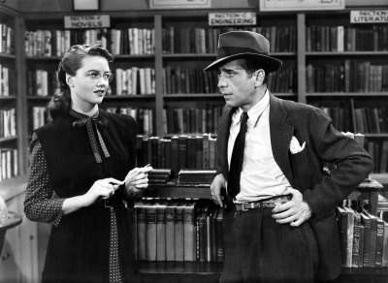
The Big Sleep had a lot of sexual undertones, and this scene explicitly did so. Marlowe interacts with a lot of women who often act flirtatious towards them. It is because they suspect he is a swarthy handsome detective, and they play along. That is something the bookstore woman explicitly does. Detective Marlowe actually has a small bottle of alcohol in his pocket in which he offers her a glass. Finally, he then asks her to take off her glasses, the screen crossfades to the window, in which she walks him out the door. With the previously mentioned films, it is safe to say that they do cement themselves within the film noir legacy. But is film noir relevant today? Yes, but current day films do not necessarily categorize them within noir. Films like The Girl on the Train, Nocturnal Animals, and Sin City do. They market themselves to be psychological thrillers, or out simply categorized dramas. These films do not have noir characteristics, like being shot in black and white, on the contrary to Sin City. These films are often shot in color but in really dark monochromatic tones, with exaggerated shadows as seen in a normal noir film. With all that in mind, noir still shows its face from time to time within select films. Film Noir is one of the most celebrated genres in cinema. The discussion of it being a genre, or a cinematic style is still debated and will be discussed for decades to come. I myself just overall love the topic of film noirs. Turner Classic Movies does a programming block called Noir Alley where host Eddie Muller, an author of many books that entail noir, will screen a film and describe the background of the movie What is nice is that Muller curates a lot of films that were B movies of the major studios in which they do not gather much cultural significance. As a fan of noir, it was a joy to research the origins of this epic realm of cinema. With all the research presented, these books mentioned a lot of noir films that often go unnoticed and forgotten even though they have cultural significance pertaining to film noir.

Works Cited

"Billy Wilder." Britannica Academic, Encyclopædia Britannica, 15 Nov. 2017. academic.eb.com/levels/collegiate/article/Billy-Wilder/76983. Accessed 19 Nov. 2018.

Barson, Michael. “Howard Hawks.” Encyclopedia Britannica, Encyclopedia Britannica, Inc., 26 May 2018, www.britannica.com/biography/Howard-Hawks.

Chaumeton, Raymond Borde, et al. A Panorama of American Film Noir 1941-1953. Translated by Paul Hammond, City Lights Books, 2002.

Gifford, Barry. Out of The Past: Adventures in Film Noir. University Press of Mississippi, 2001.

"Howard Hawks." Britannica Academic, Encyclopædia Britannica, 4 Jun. 2014. academic.eb.com/levels/collegiate/article/Howard-Hawks/39617. Accessed 26 Nov. 2018.

Hawks, Howard, director. The Big Sleep. Warner Brothers, 1946.

Pippin, Robert B. Fatalism in American Film Noir. University of Virginia Press, 2012.
Sehayek, Marnie. “A Very Brief History Of Film Noir.” Culture Trip, 17 Aug. 2016, theculturetrip.com/north-america/usa/california/articles/a-very-brief-history-of-film-noir/.

“Sunset Boulevard: The Film That Fought Back.” The Independent, Independent Digital News and Media, 3 Feb. 2014, www.independent.co.uk/arts-entertainment/films/features/sunset-boulevard-the-film-that-fought-back-122157.html.

Thomson, David. The Big Screen: The Story of Movies. 2012.

Wilder, Billy. Conversations With Wilder. Knopf , 2001.

Wilder, Billy, director. Double Indemnity. Paramount Pictures, 1944.

Wilder, Billy, director. Sunset Boulevard. Paramount Pictures, 1950.

